EE463 Software Project 1

Single Phase Diode Rectifiers

*Contributors: Batuhan Bülbül & Mert Elmas*

1.

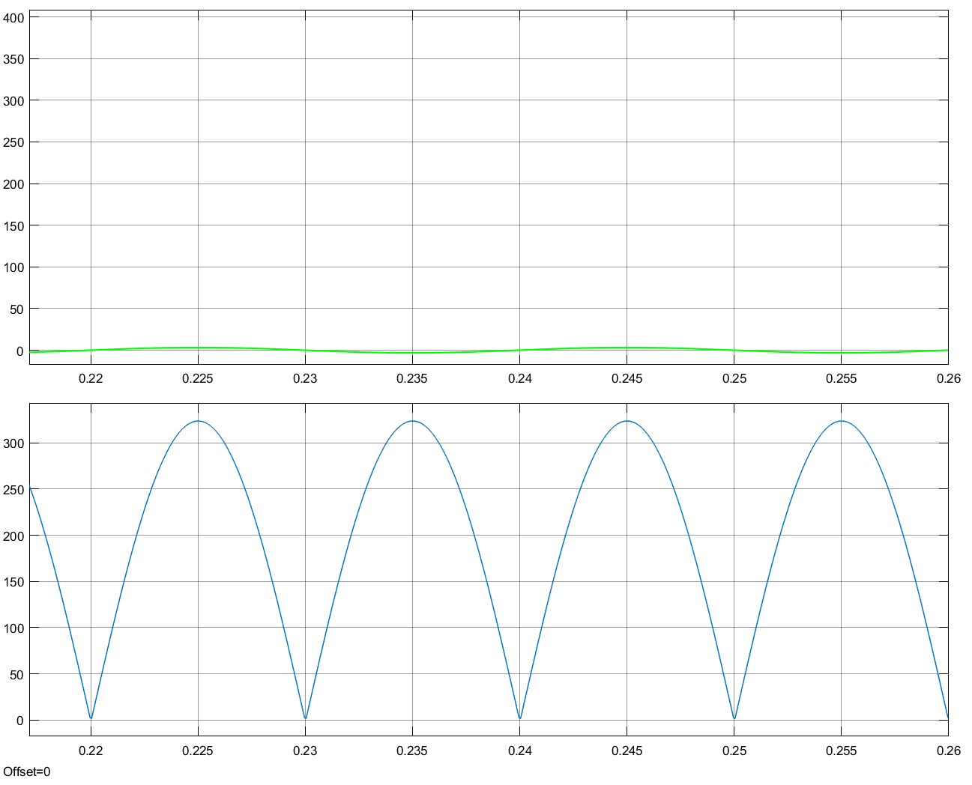

Figure 1: Output voltage waveform for 10µs case

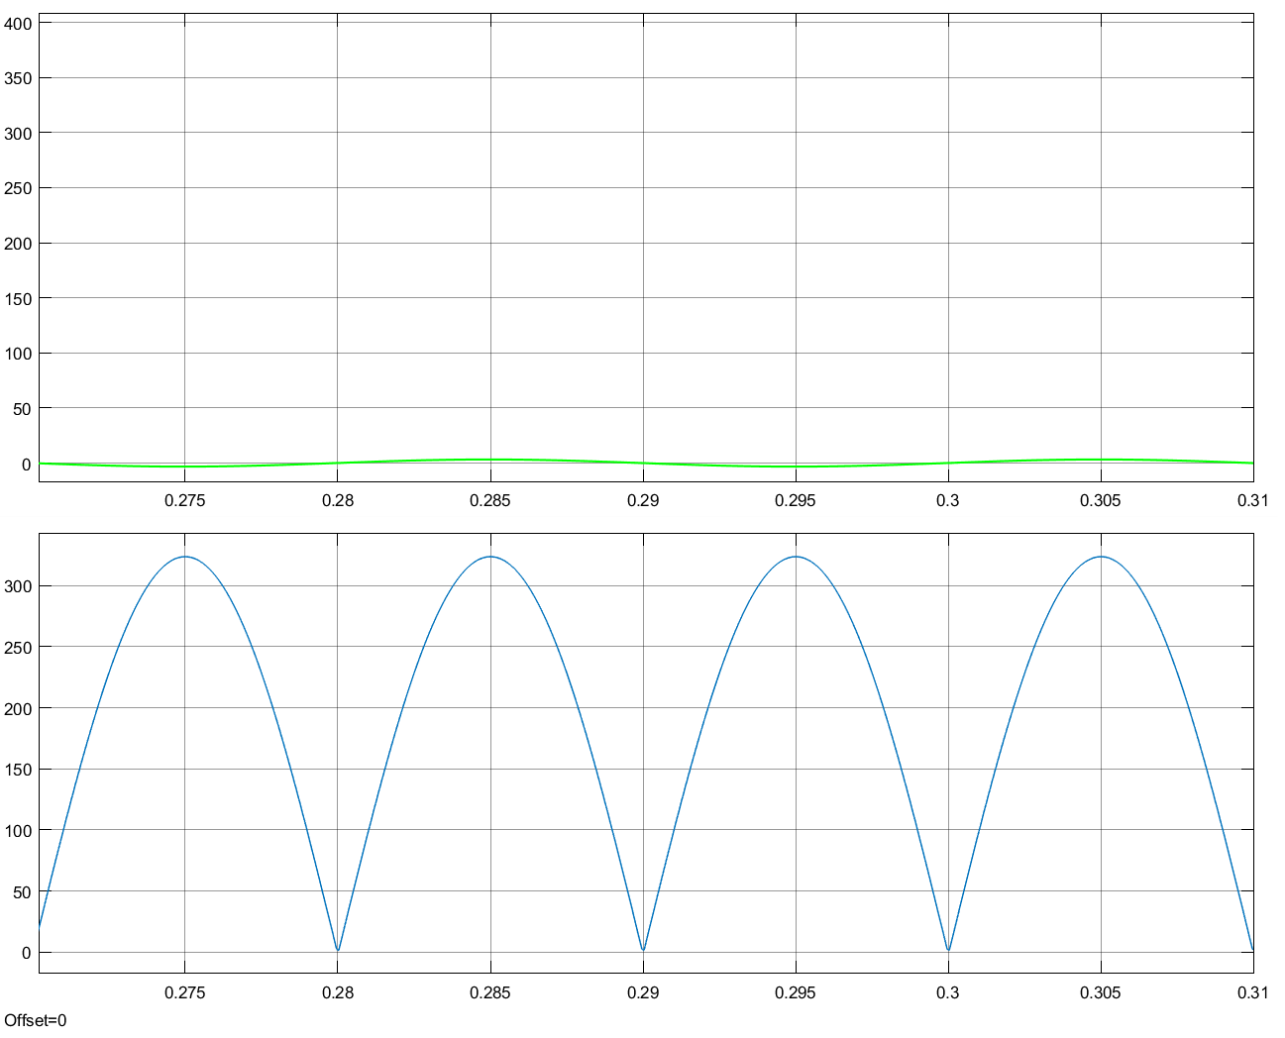

Figure 2: Output voltage waveform for 1µs case

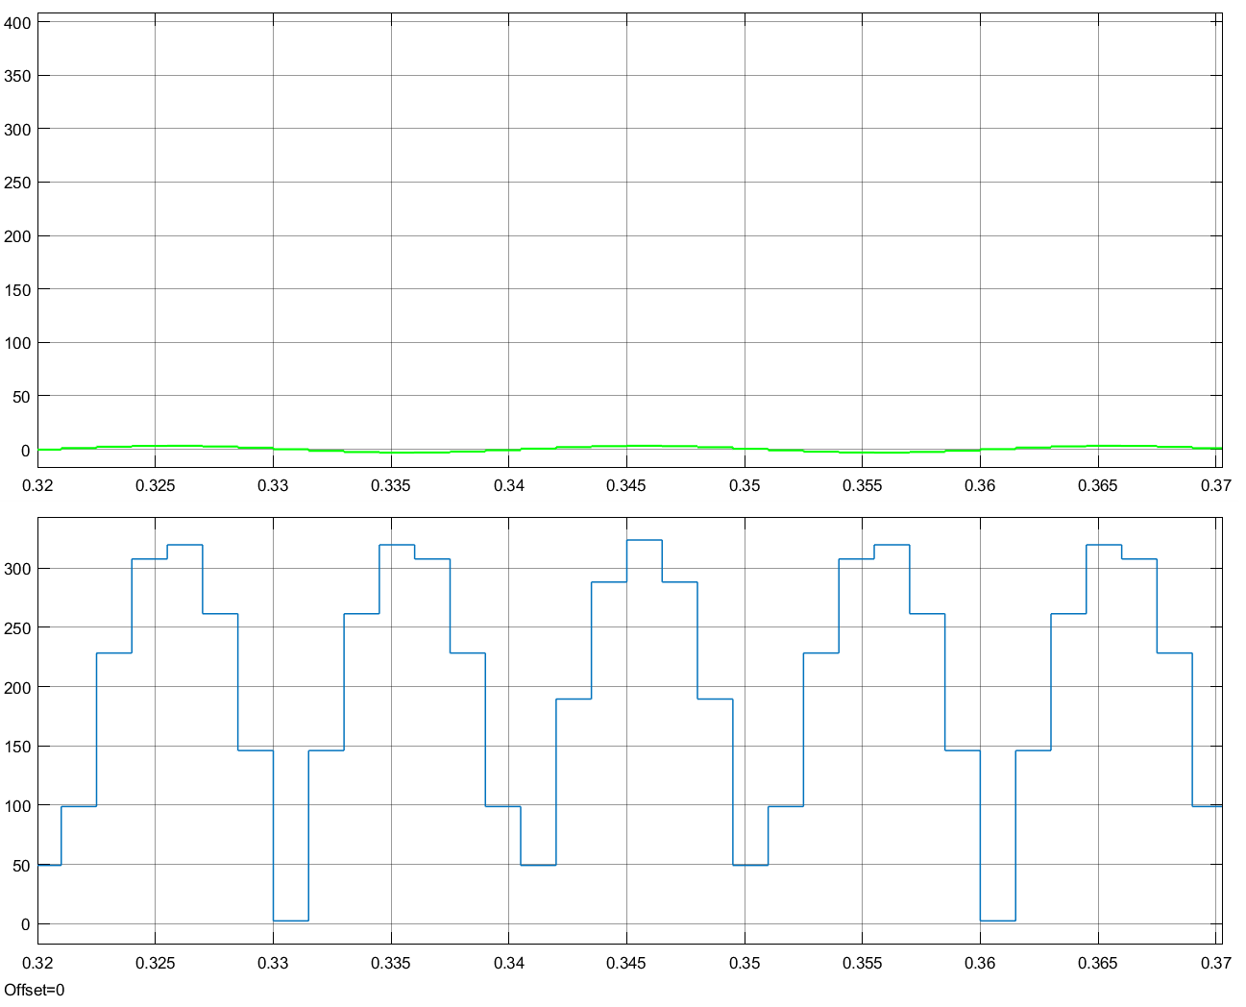

Figure 3: Output voltage waveform for 1.5ms case

This part is important in showing the right usage of the step size since as it is demonstrated in figure 3 as the step size becomes comparable to the period of the signal the waveform becomes distorted.

2.1.1

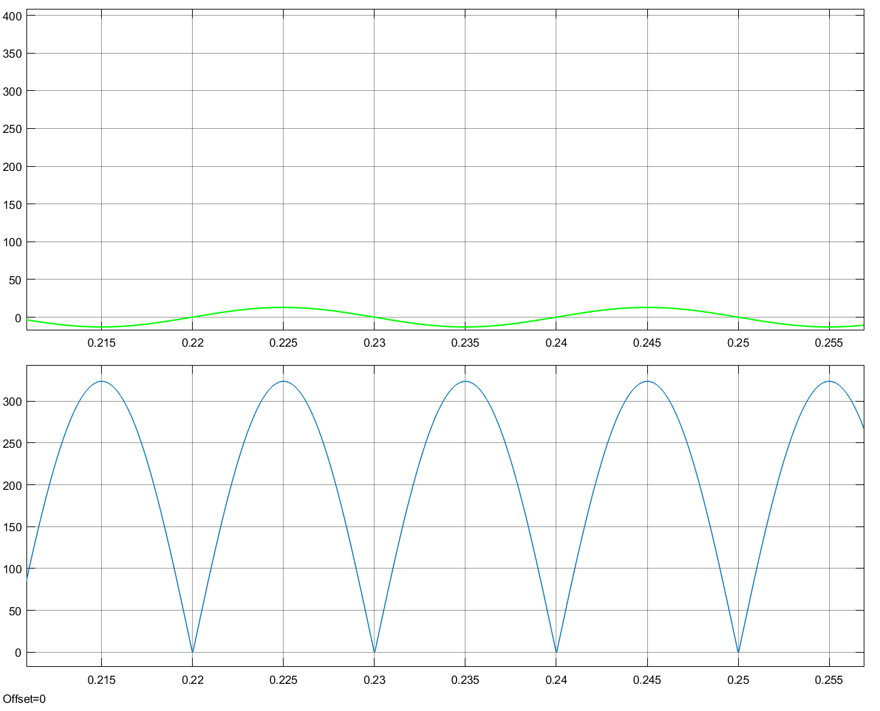Figure 4: Output voltage waveform for RLoad=25 Ω

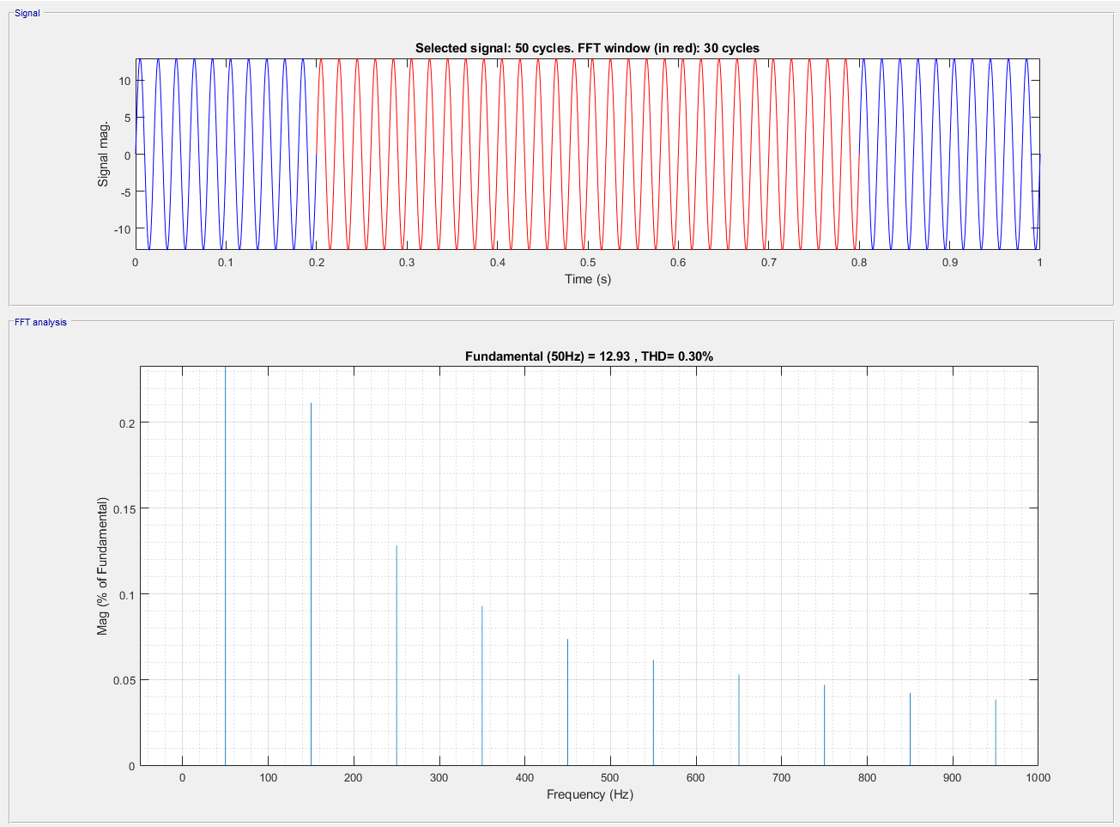

Figure 5: Graphical analysis of THD for RLoad where R=25 Ω

As can be seen from the bar graph the value of the THD is found to be 0.3%.

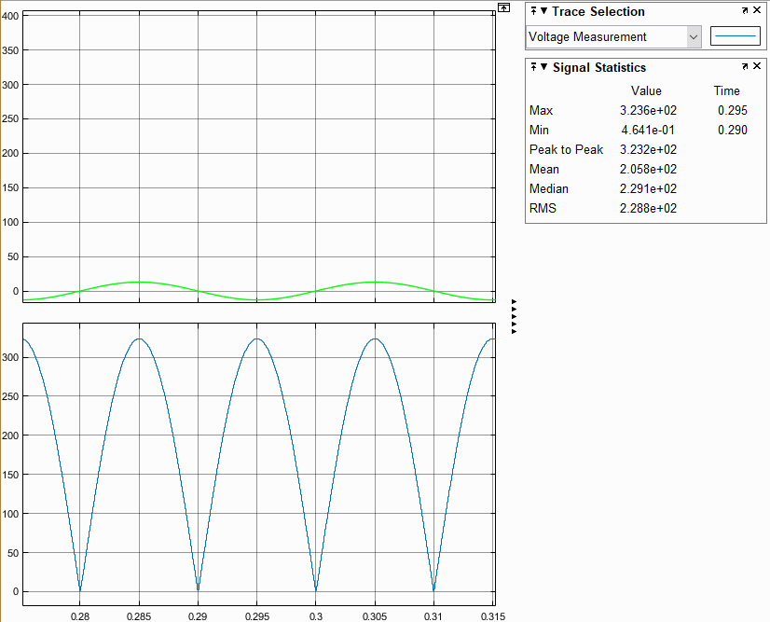

Figure 6: Graphical analysis of the output voltage where the average value of it is found to be 205.8V where RLoad=25 Ω

2.1.2

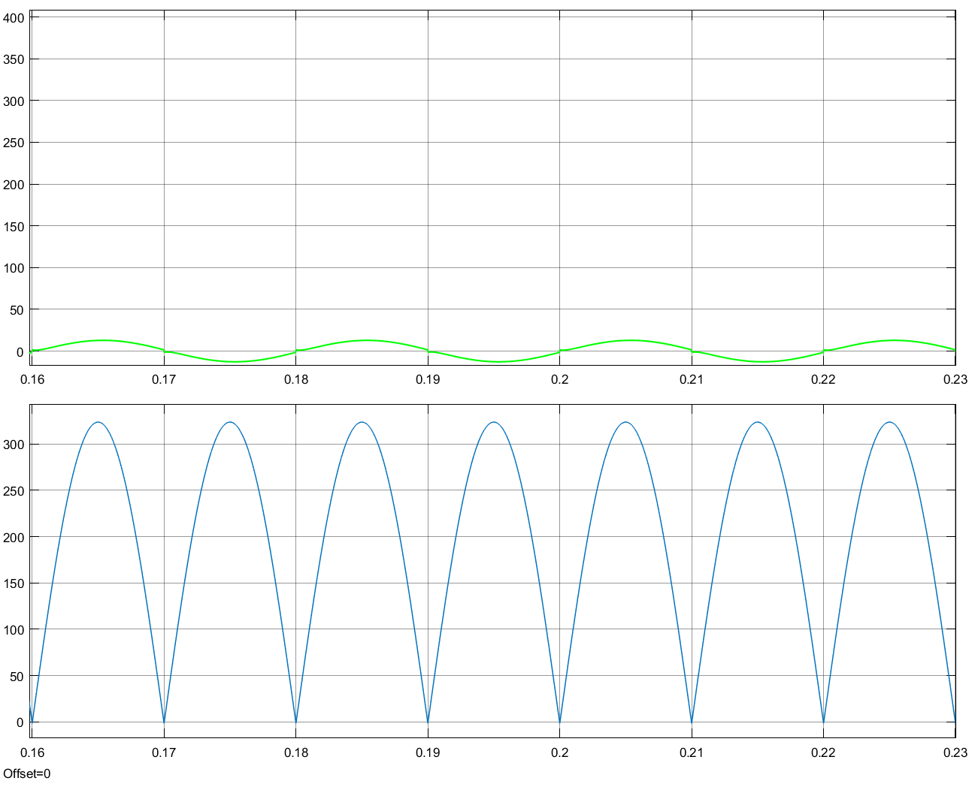

Figure 7: Output voltage waveform for RL load where R=25 Ω & L=10mH

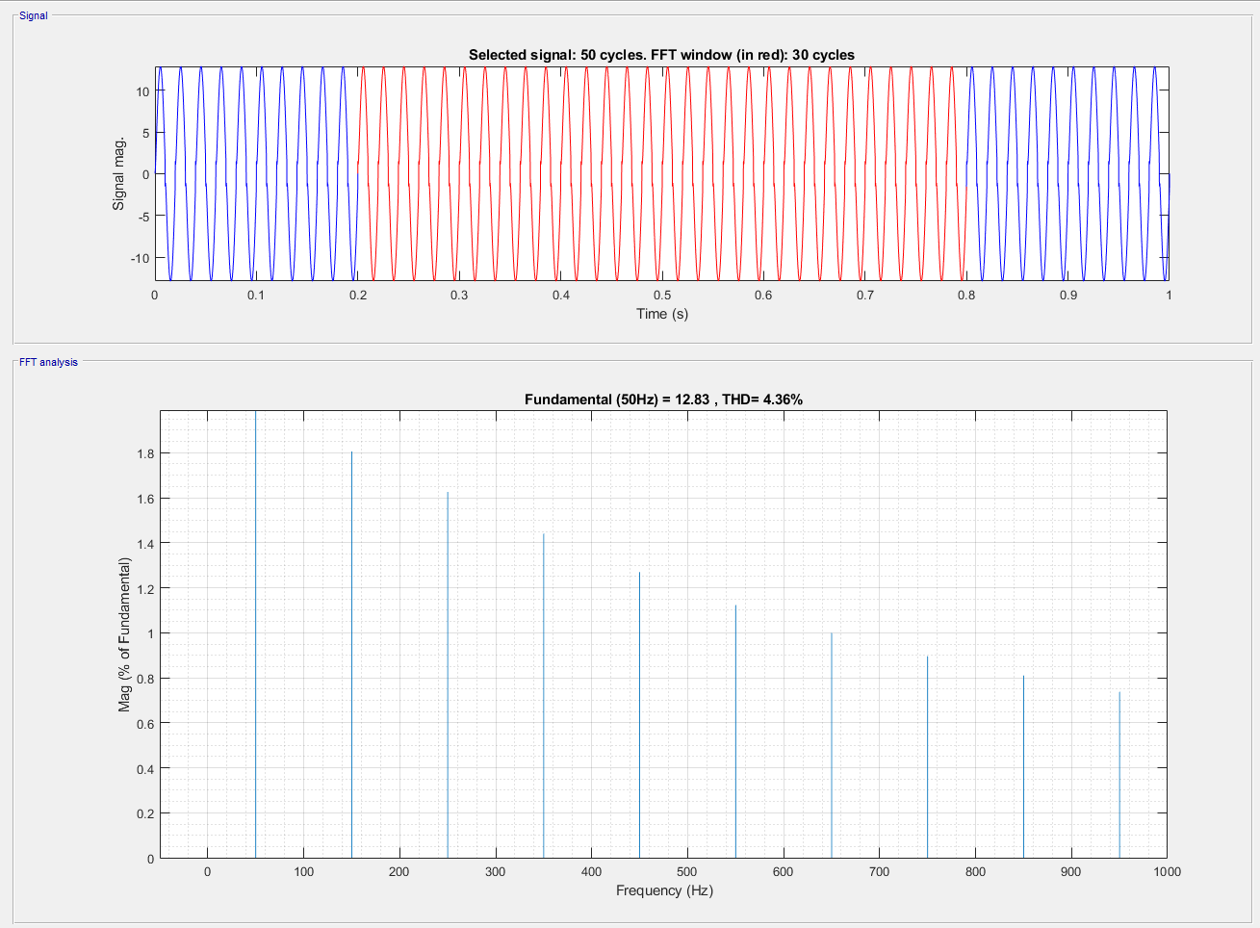

Figure 8: Graphical analysis of THD for RL Load where RLoad=25 Ω L=10mH

As can be seen from the bar graph the value of the THD is found to be 4.36%.

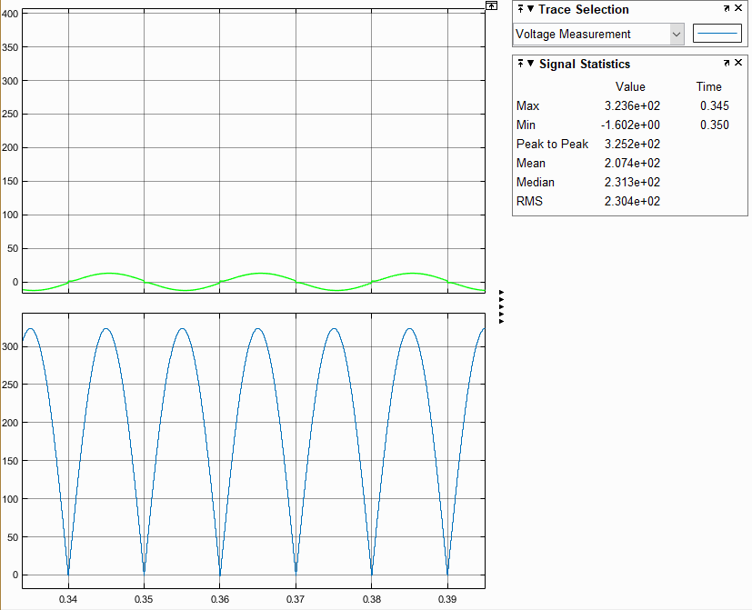

Figure 9: Graphical analysis of the output voltage where the average value of it is found to be 207.4V where RLoad=25 Ω & L=10mH

2.1.3

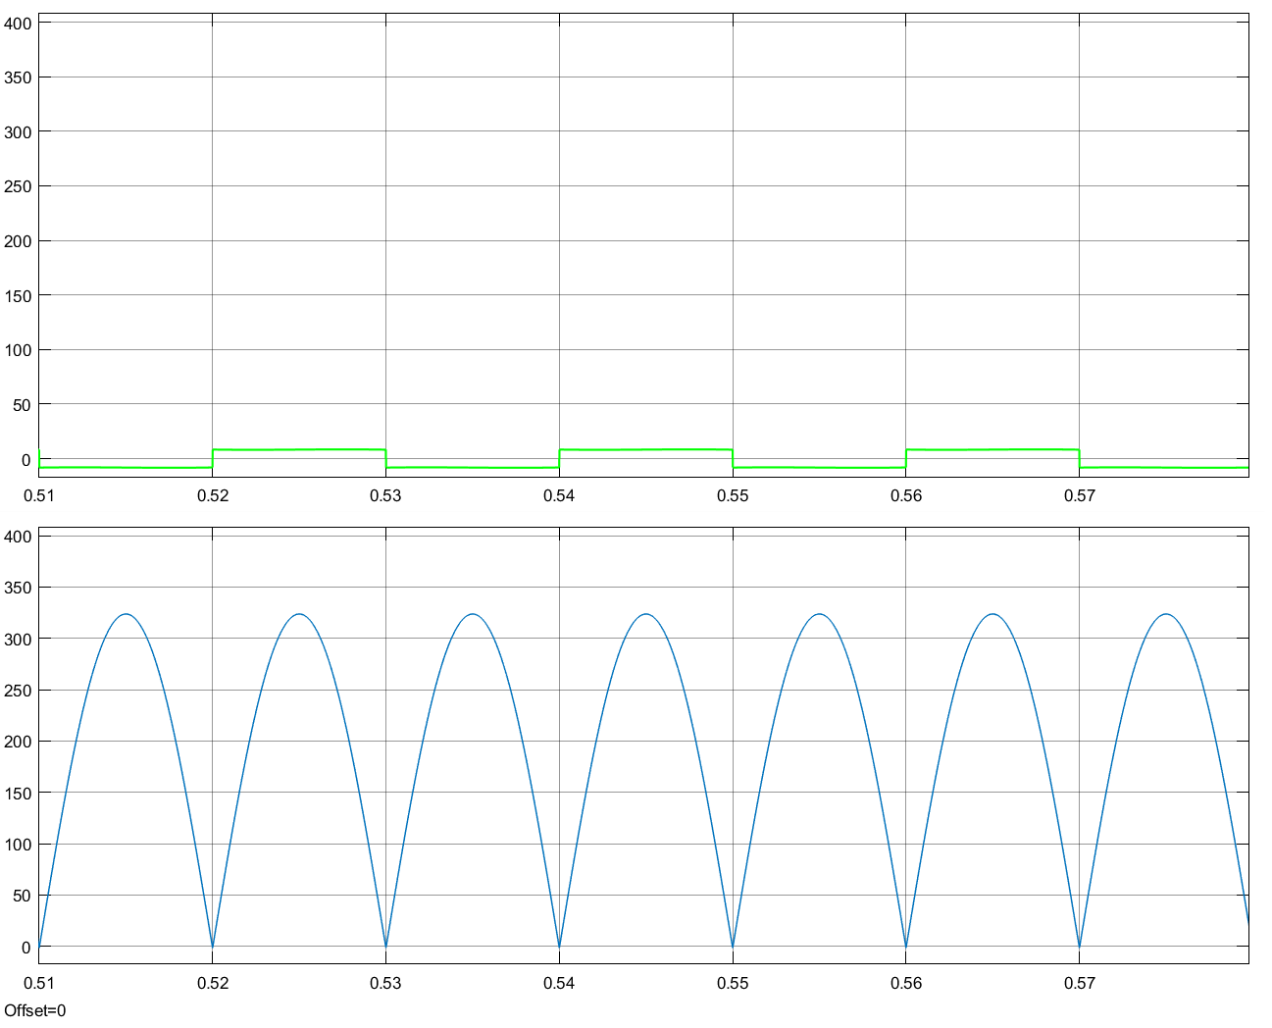

Figure 10: Output voltage waveform for RLoad = 25 Ω & L=1H

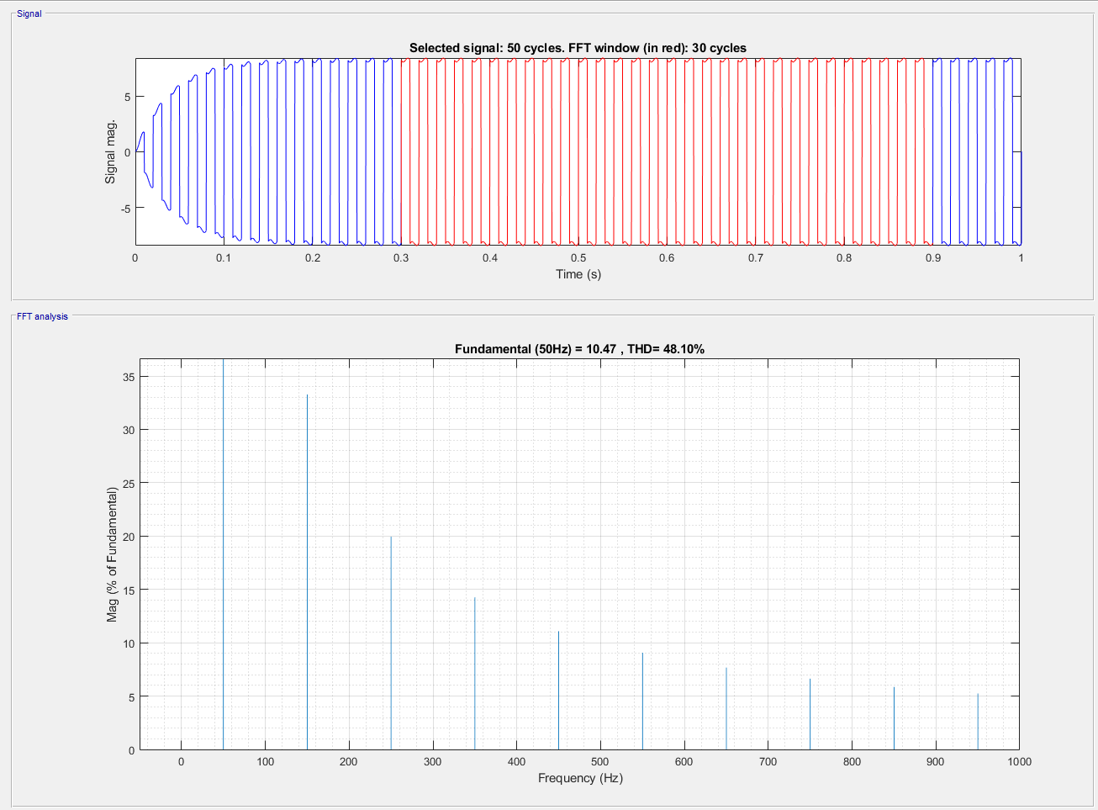

Figure 11: THD= 48.1% with RL Load R=25 Ω L=1H

2.2

Selected diode to construct a single-phase rectifier is *MBR2H200SFT3G*

Datasheet provided in the following link <https://www.onsemi.com/pub/Collateral/MBR2H200SF-D.PDF>

Selected single phase diode rectifier is *CD2320-B1400-ND* datasheet provided in the following link<https://media.digikey.com/pdf/Data%20Sheets/Bourns%20PDFs/CD2320-B1.pdf>

2.3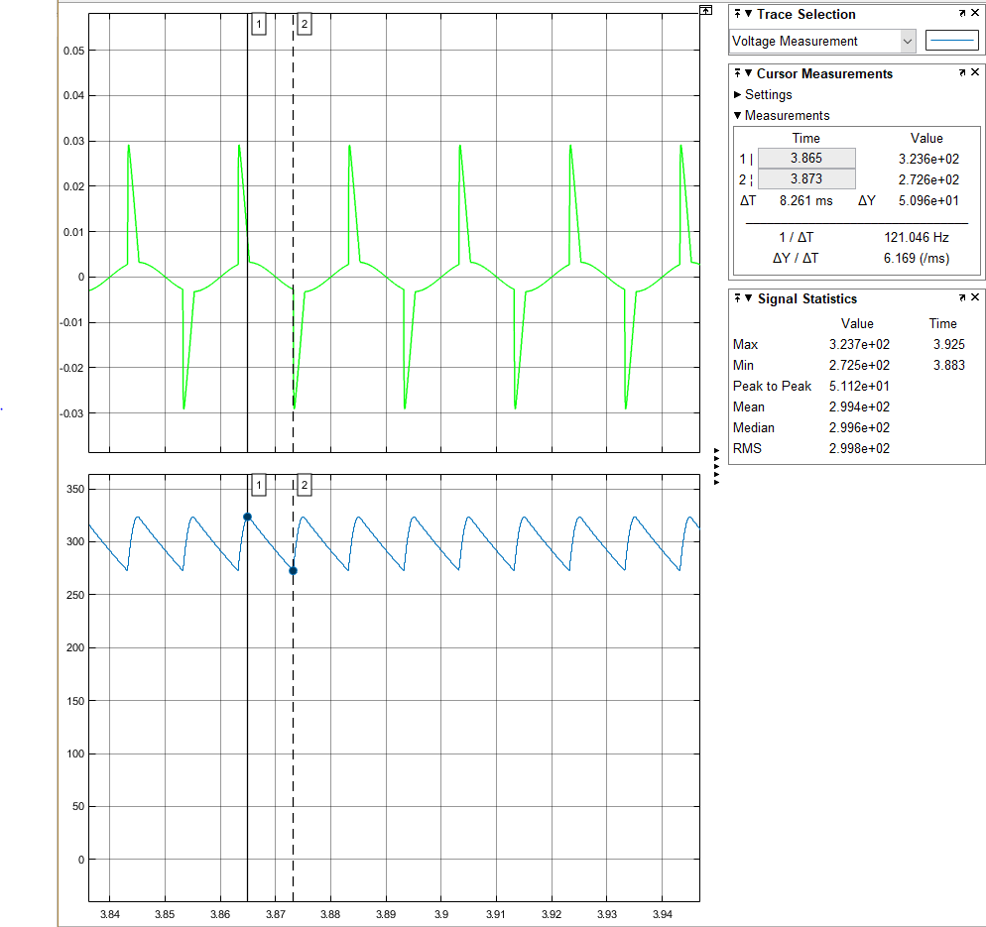

Figure 12: Output voltage waveform with RC load R=100 Ω C=0.47uF

<http://www.chemi-con.co.jp/cgi-bin/CAT_DB/SEARCH/cat_db_al.cgi?e=e&j=p&pdfname=smg> is a link to selected capacitor datasheet and manufacturer code is *ESMG351ELLR47MF11D*

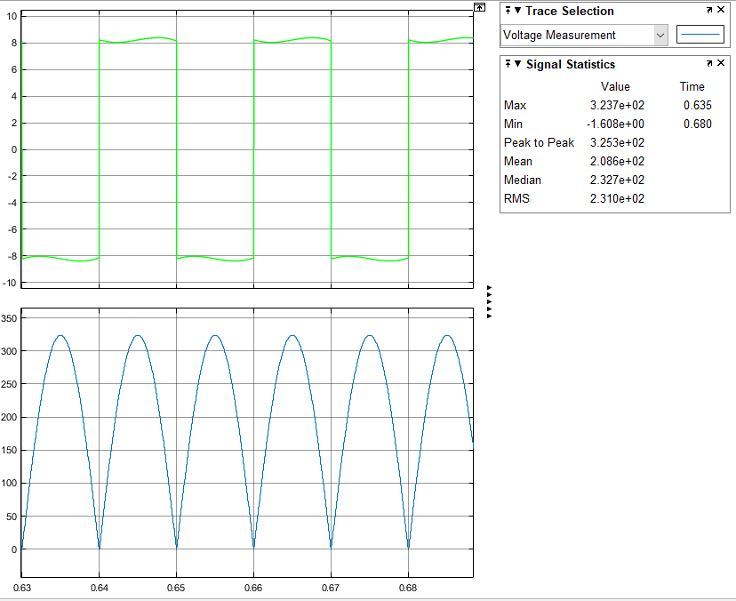

Figure 13: Average output voltage is 208.6V with RL Load R=25 Ω L=1H

2.4

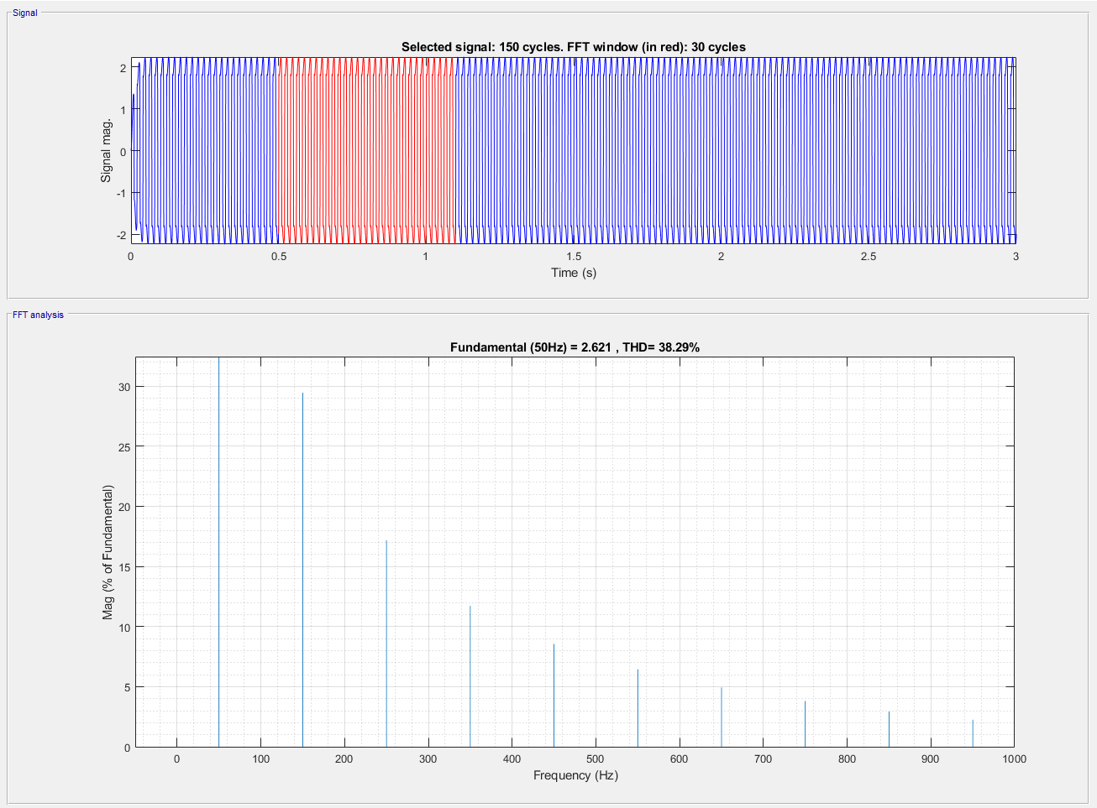

Figure 14: THD= 38.29% with RL Load R=25 Ω L=1H and line inductance of 10mH

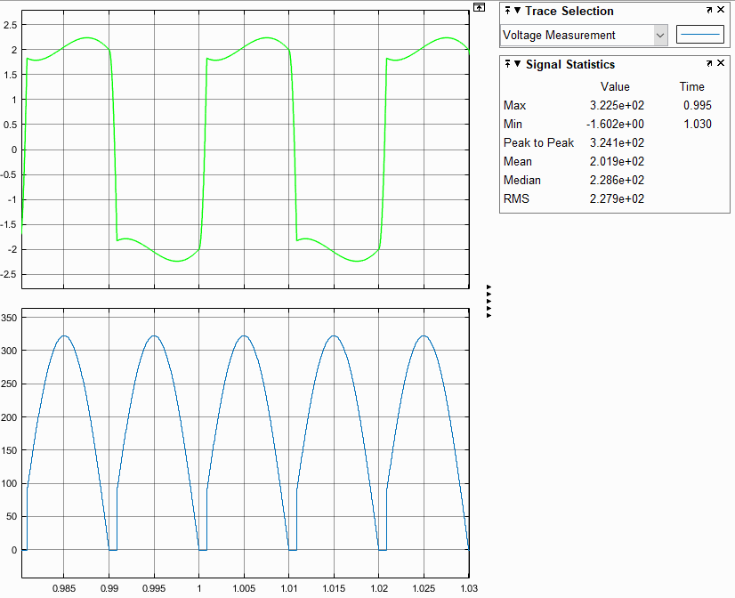

Figure 15:

Average output voltage is 201.9V

2.5

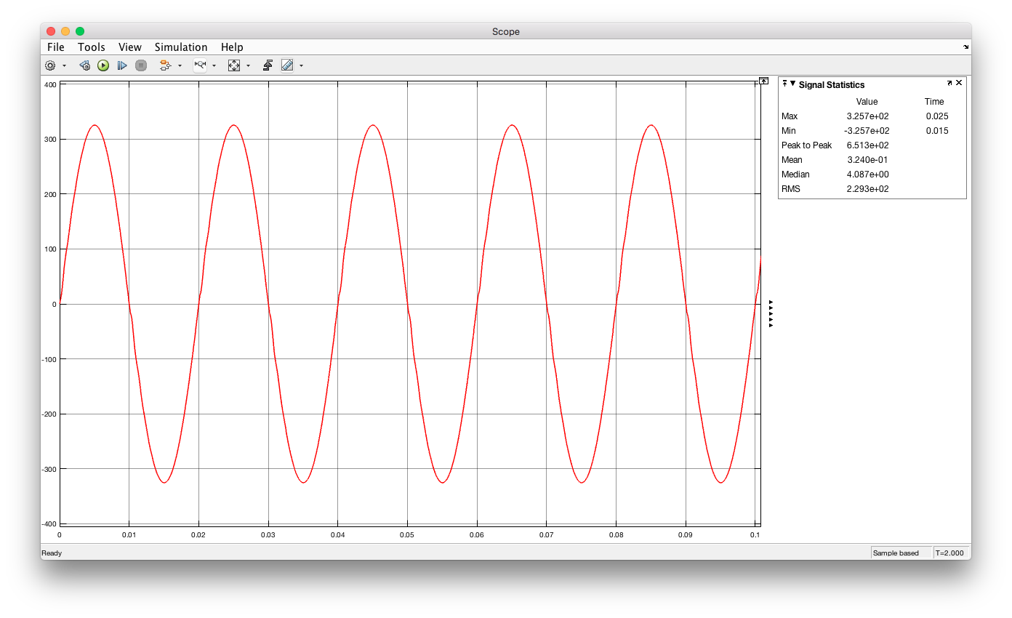

Figure 16: Graphical analysis for the given system from the textbook where the Cd value is 20µF.

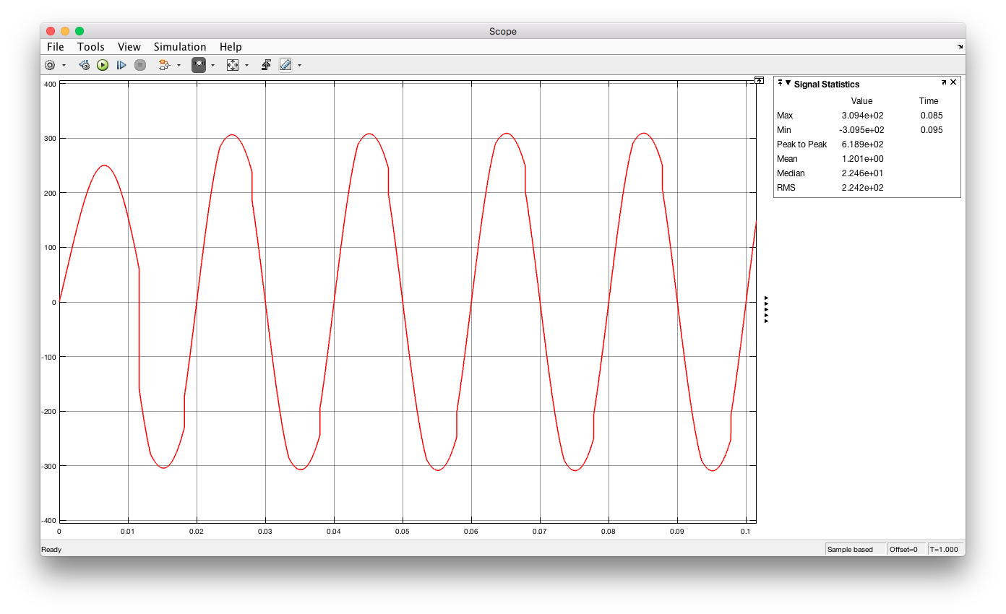

Figure 17:Graphical analysis for the given system from the textbook where the Cd value is 20mF.

As it can clearly be seen from the graphs in figure 16 and 17 waveform is distorted when we change the value of the load capacitance. Therefore it is important to pay attention to the circuit dynamics and make adjustments when it is necessary in the form of adding capacitances or inductances.

3.1

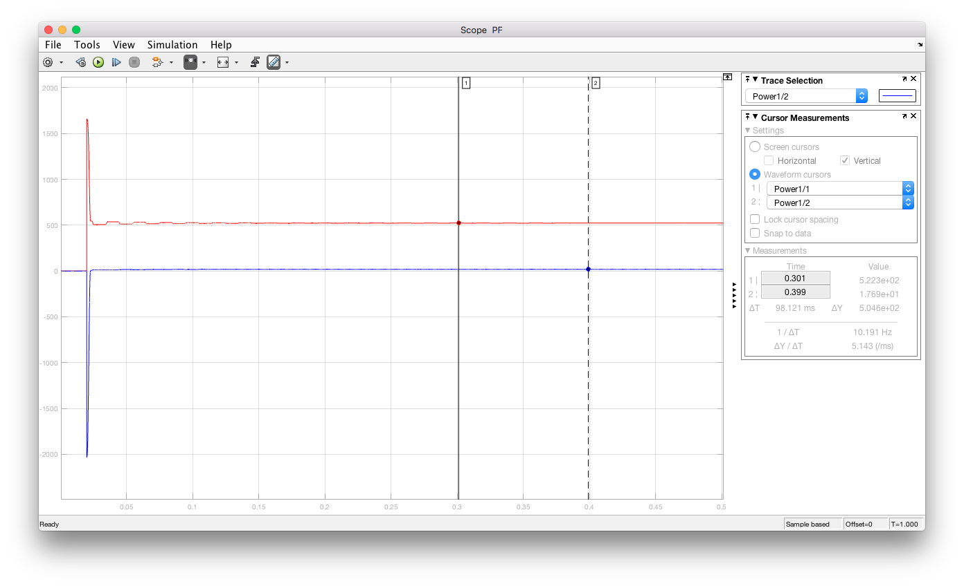

Figure 18: Graphical data obtained for real and reactive powers seen from the input side for the first case.

From this graph we can conclude that the power factor is 0.999 leading which is understandable since grid inductance and load capacitance balance each other out.

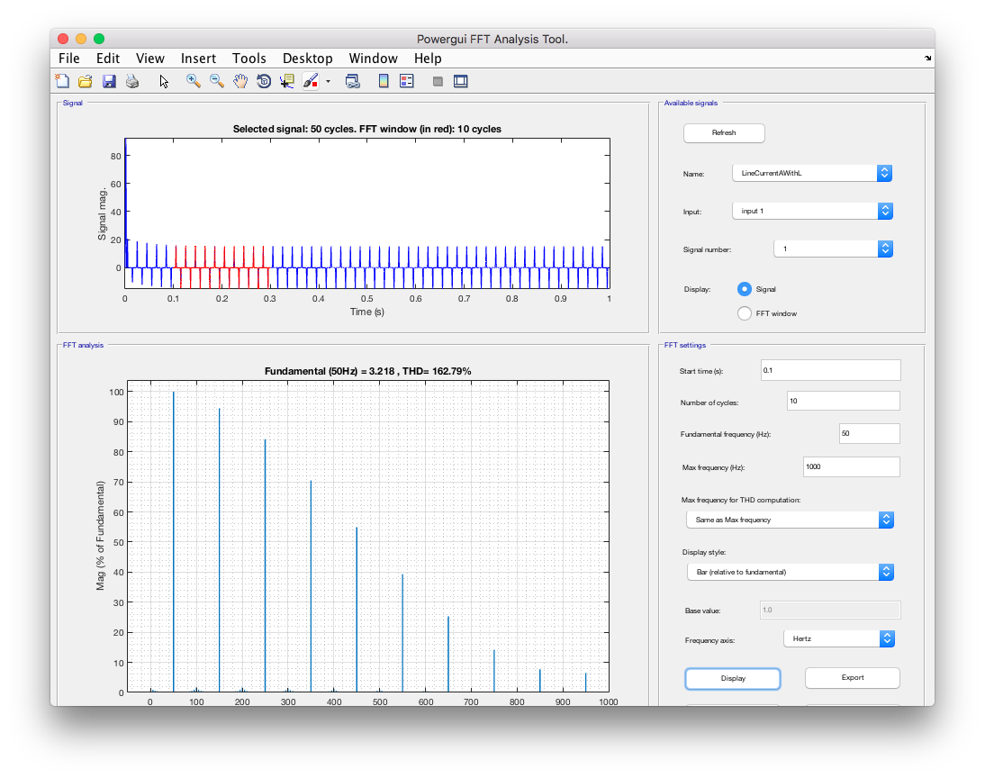

Figure 19: Graphical data obtained for THD analysis for the first case.

As it is evident from the bar graph in figure 2 the THD value of input current is 162.79%. This means the effect of the harmonics is high which is not desirable.

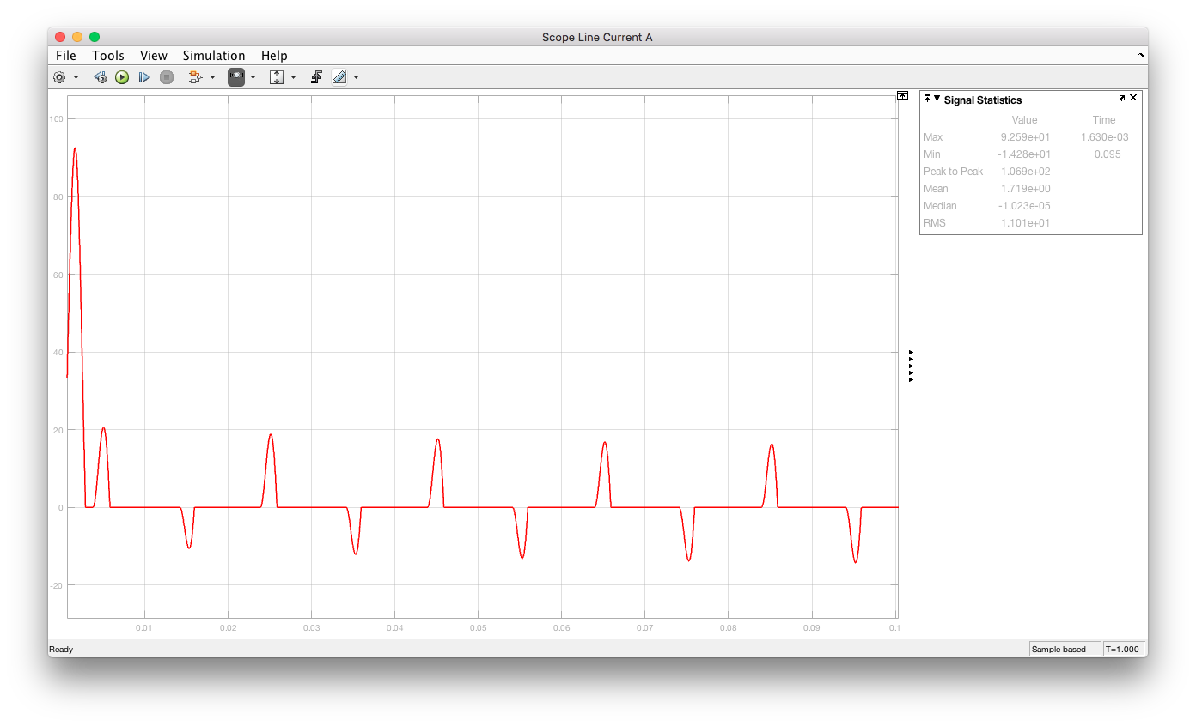

Figure 20: Graph for phase-A current for the first case.

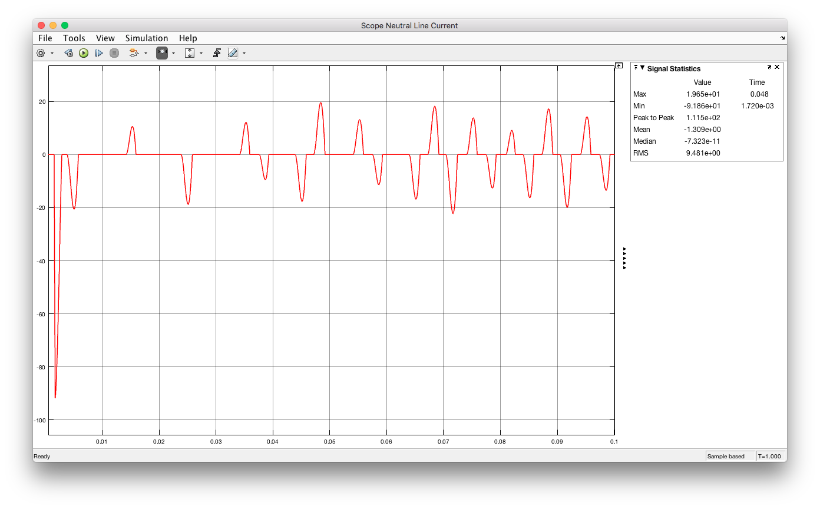

Figure 21: Graph for neutral wire current for the first case.

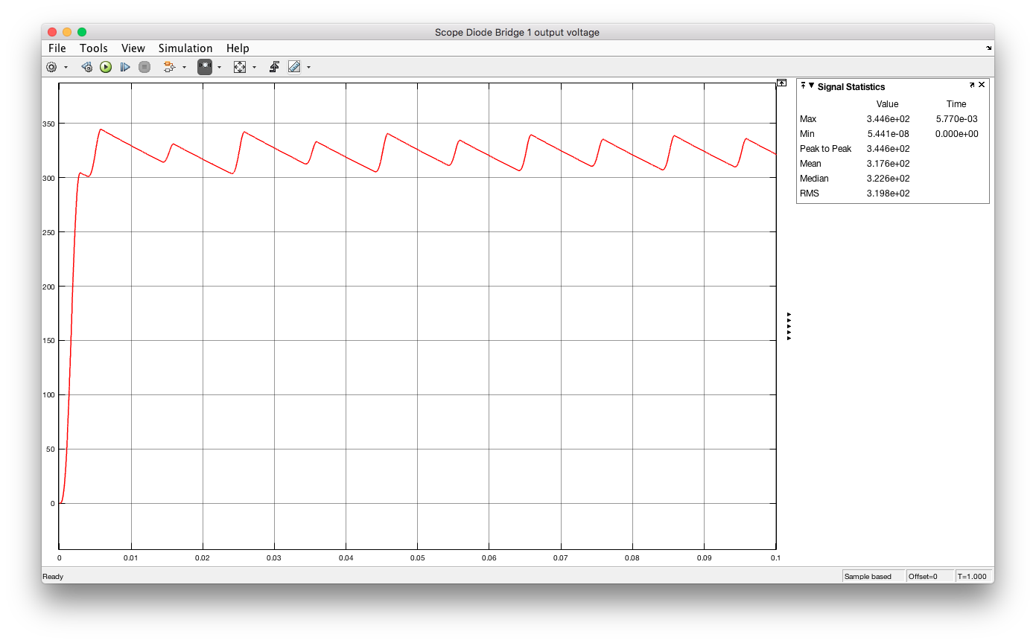

Figure 22: Graph for Diode Bridge 1 output voltage for the first case.

3.2

As can be read from the graphs RMS value for the line current A is 11 Arms and as far as the other lines are concerned they are close to this value (7.55Arms for line B and 8.95 Arms for line C).

As for the neutral line current, the RMS value is 9.48 Arms.

For a balanced 3 phase system neutral line current is expected to be a flat 0 line and therefore for its rms to be zero however rectification creates harmonics and changes this. Hence the rms value is not zero for neutral line current.

3.3.1

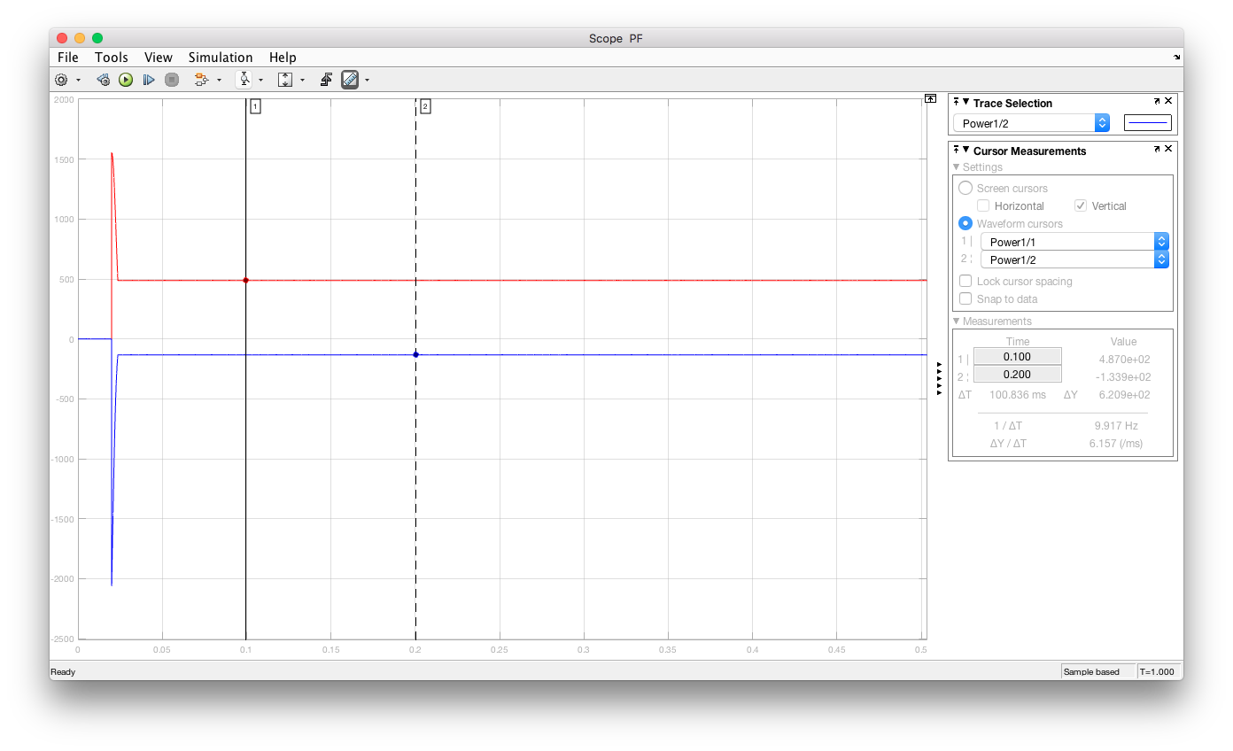

Figure 23: Graphical data obtained for real and reactive powers seen from the input side for the second case

From this graph we can conclude that the power factor is 0.96 leading which is slightly different from the first case but different nonetheless. This difference is caused by the lack of the grid inductance.

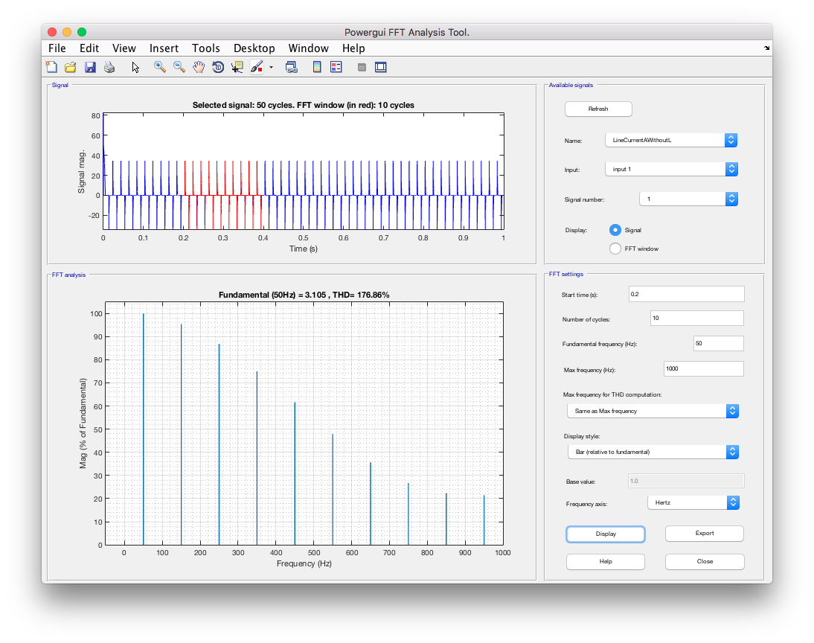

Figure 24: Graphical data obtained for THD analysis for the second case.

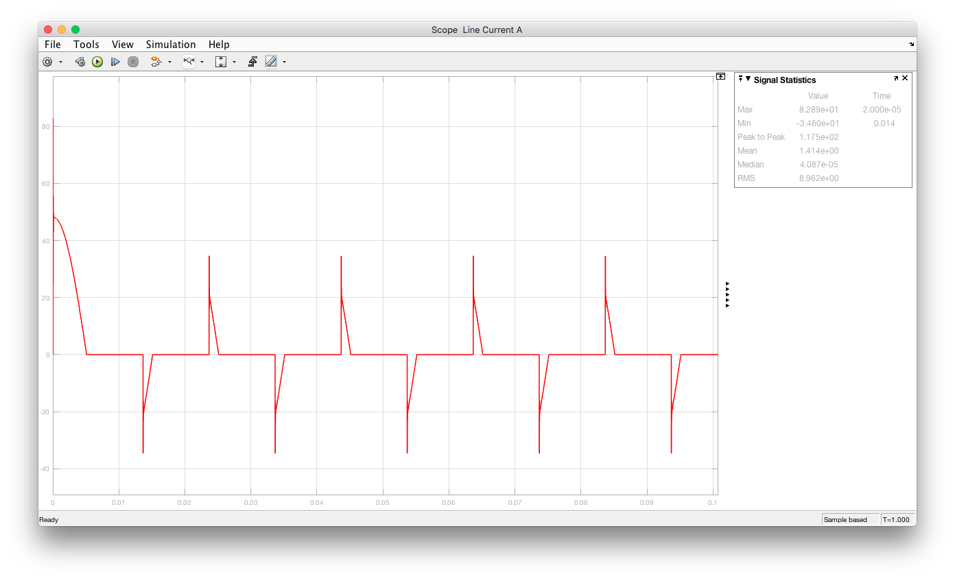

Figure 25: Graph for phase-A current for the second case.

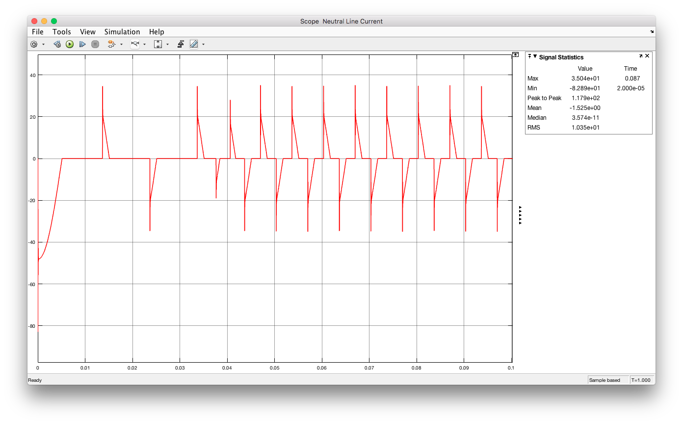

Figure 26: Graph for neutral wire current for the second case.

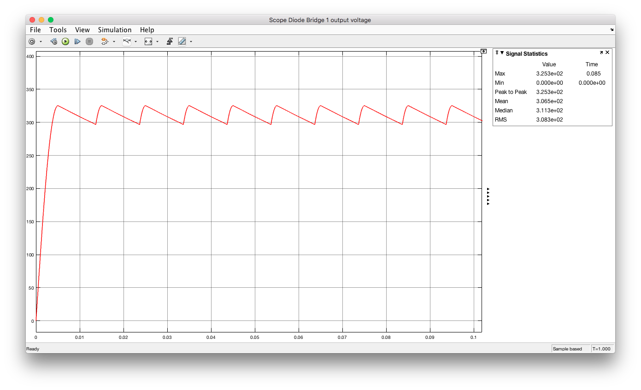

Figure 27: Graph for Diode Bridge 1 output voltage for the second case.

3.3.2

As can be read from the graphs RMS value for the line current A is 8.96 Arms and as far as the other lines are concerned they are close to this value (7.64Arms for line B and 7.64 Arms for line C).

As for the neutral line current, the RMS value is 8.48 Arms.

Compared to the first case phase A current and neutral line current become sharper due to the lack of Ls this means that an inductor in the system smooths the current waveforms due to the following relationship: